We have some Global methods which are super handy and useful In JavaScript

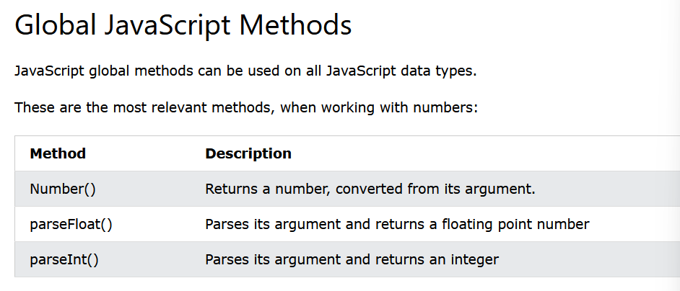

Number( )

It converts anything we pass it to a Number data type

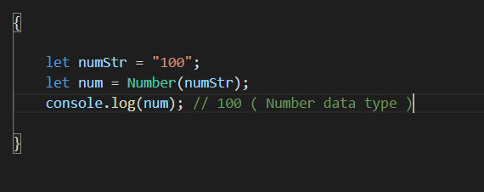

parseFloat ( )

We can obtain the float if it is the string form

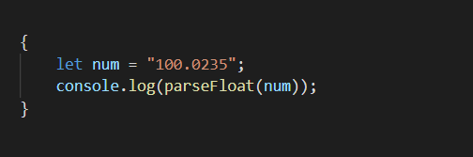

But seems like Number ( ) also does similar

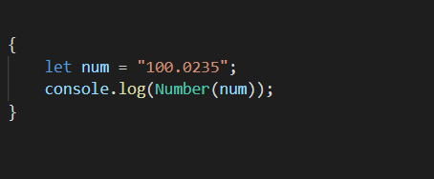

parseInt( )

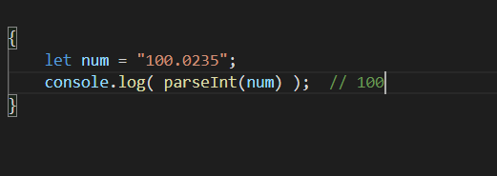

It returns us int

**Cases where parseFloat( ) and parseInt( ) becomes super useful than the Number( )**

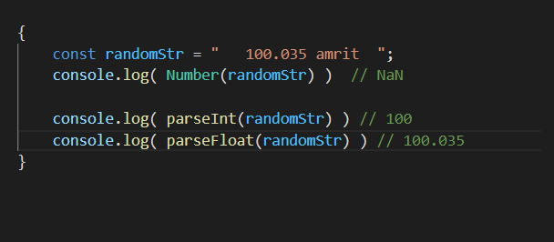

See we just extracted int and float from the messy and annoying string